HTTP and Burp Suite
Introduction and Lab Report
Lab: Basic Password Reset Poisoning — PortSwigger Web Security Academy
Prepared by: Nihar Mane

Index

Part 1 — Introduction

1.1 What is HTTP? ……………………………………………………………………………………………2

1.2 HTTP Methods………………………………………………………………………………………….....2

1.3 Status Codes………………………………………………………………………………………………3

1.4 Headers………………………………………………………………………………………………….....3

1.5 Cookies……………………………………………………………………………………………………..4

1.6 Parameters…………………………………………………………………………………………………4

1.7 Burp Suite Proxy…………………………………………………………………………………………..5

1.8 HTTP History………………………………………………………………………………………………5

1.9 Repeater………………………………………………………………………………………………5

1.10 How They Interconnect …………………………………………………………………………………5

Part 2 — Lab Report Template

2.1 Report Metadata…………………………………………………………………………………………6

2.2 Executive Summary…………………………………………………………………………………….6

2.3 Scope…………………………………………………………………………………………………….7

2.4 Methodology……………………………………………………………………………………………..7

2.5 Step-by-Step Execution…………………………………………………………………………………8

2.6 Impact Assessment…………………………………………………………………………………….17

2.7 Remediation……………………………………………………………………………………………..18

2.8 Conclusion………………………………………………………………………………………………18

References……………………………………………………………………………………………………………19

Part 1 -> Introduction

1.1 What is HTTP?
It stands for Hypertext Transfer Protocol (HTTP). It’s a request/response protocol that browsers and servers use to exchange data/information on the web. It also has a new updated version called Hypertext Transfer Protocol Secure (HTTPS). The difference between the two is

Features | Hypertext Transfer Protocol (HTTP) | Hypertext Transfer Protocol Secure (HTTPS)
Security | None | SSL (Secure Sockets Layer)/TLS (Transport Layer Security)
Default Port Number | 80 | 443
Data Protection | Data is exchanged as plain text | Data is encrypted before exchange
Authentication | Doesn’t verify website identity | Uses digital certificates to see the website's identity.
Integrity | Data can be tampered/ altered/ modified while exchanging. | Prevents data from being tampered with/altered/modified while exchanging.
URL Prefix | http:// | https://
Browser Indicator | “Not Secure” | “Padlock Icon”

Client (Browser)
|
| HTTP Request (Plain Text)
|
Web Server <- Working Diagram
|
| HTTP Response (Plain Text)
|
Client (Browser)

1.2 HTTP Methods

METHOD | DESCRIPTION
GET | Request a resource. Usually sent via a URL string and from the client side.
POST | Submit data for processing. Happens on the server side. E.g., respond to an initial query, update the data if a back-and-forth exchange of data happens, etc.
PUT | Replaces a resource entirely at a given URL
DELETE | Removes a resource at a given URL.
HEAD | Same as GET but only with headers and no body.
OPTIONS | Asks the server what options are available for communication
TRACE | Performs a loopback test from client-server-client.
PATCH | Applies partial modifications. Unlike PUT, which replaces the entire resource, PATCH changes only the specified fields.
CONNECT | Establishes a tunnel from the client browser to the server. HTTPS is commonly used but connects through an HTTP proxy.
QUERY | Sends a query from the client to the server. Uses the GET method.

1.3 Status Codes

These are 3-digit codes returned by the server as an outcome of the client’s request. The 1st digit says the class of response. Example: 404 missing webpage, 500 server failure, etc.

STATUS CODES | DESCRIPTION
1xx: INFORMATIONAL | Shows the result that the data was received and processing continues. Eg:, 100,101
2xx: SUCCESS | Shows that the request from the client side was received and processed. E.g., 200, 201, 202
3xx: REDICTION | States that the response needs further action when trying to complete the request. E.g., 301
4xx: CLIENT ERROR | Requests done by the client can't be processed. E.g., 403,404 etc.
5xx: SERVER ERROR | The server can’t process the request given by the client. E.g., 500,501 etc.

1.4 Headers

It allows the client browser and server to pass additional information in the form of request and response. There are different types of headers

HEADER | DESCRIPTION
Request headers | Contain more information about the resource to be fetched, or about the client requesting the resource.
Response headers | Hold additional information about the response, like its location or about the server providing it.
Representation headers | Contains information on resources like encoding/decofing.
Payload headers | It contains information and data, including content length and the encoding used for transport.
End-to-end headers | It must only be transmitted to the end point, i.e., the client to the server or vice versa.
Hop-by-hop headers | Only used for a single transport-level connection. Must not be used by proxies or recaching.

1.5 Cookies

Cookies are small files that reside in the client browser, which contain some information given by the website. There are different types of cookies.

COOKIES | DESCRIPTION
Session cookie | Track user session. Deletes after session ends.
Persistent cookies | Remain in the system for a defined time.
Authentication cookies | Used to authenticate the user while login/signup.
Tracking cookies | Used to track services and user activity.

1.6 Parameters

A resource locator used to request data from a specific resource on the web. Parameters are the data points a client sends to the server: in the URL query string (GET), in the request body (POST/PUT), or occasionally in headers or cookies. Nearly every category of web vulnerability—injection, IDOR, and access control—comes down to a parameter value the server didn't validate or authorize correctly. Types of parameters are

PARAMETERS | DESCRIPTION
Query string | key-value pairs appended to the end of a URL to pass data to a web server or application
Path string | variable segments embedded directly inside a URL path to identify a specific resource
Request body | Data elements sent from a client to a server during an HTTP request to customize, filter, or supply input for a specific operation
Header | One can find these in the request header; they’re usually related to authorization.
1.7 Burp Suite Proxy

It operates as a web proxy server between the browser and target applications. It enables you to intercept, inspect, and modify traffic that passes in both directions. You can even use this to test using HTTPS. It works with Burp's browser to access the target application. To launch Burp's browser, go to Proxy > Intercept and click Open Browser. All traffic for this browser is proxied through Burp automatically.

1.8 HTTP History

HTTP History tab logs every request and response that has passed through Burp, even with intercept switched off. This is usually the more practical day-to-day view: browse the target normally, then go back through history to find interesting requests to test further—for example, the exact login request format, or a request carrying an ID parameter worth probing.

1.9 Repeater

Repeater lets you take a captured request, edit it freely, and resend it as many times as needed while comparing responses side by side. It's the main tool for manually testing a hypothesis: changing a parameter value, removing a header, altering an ID, and observing how the server reacts each time. Sending a request to Repeater (Ctrl/Cmd+R, or right-click > Send to Repeater) from Proxy history is the standard workflow.

1.10 How They Interconnect

These concepts form a single chain that the lab in Part 2 exercises end to end: an HTTP request carries a method, headers and parameters; the server's response carries a status code; Burp Proxy captures that request/response pair in HTTP History; and Repeater is used to edit one specific piece of it — in this case, the Host header — and resend it to observe how the server's behaviour changes. The vulnerability in this lab exists precisely because the server treats a client-controlled header (Host) as trustworthy input when generating a security-sensitive value (the password reset link).

PART 2 -> Lab Report

2.1 Report Metadata

Feild | Value
Lab Name | Basic password reset poisoning
Provider | PortSwigger Web Security Academy
Vulnerability class | Vulnerability class Host header injection → password reset poisoning → account takeover
Difficulty | Apprentice
Target | PortSwigger Web Security Academy training instance
Tools used | Tools used Burp Suite Community Edition v2026.7.2, Burp's built-in browser, exploit server
Test account | wiener (attacker-controlled)
Target account | carlos (victim)
Date tested | 2 August 2026

2.2 Executive Summary

This engagement focused on the "password reset poisoning" lab on the PortSwigger Web Security Academy. The application creates the domain part of its password reset links from the client-provided Host header instead of using a fixed server-trusted value. This allows the link to be directed to a domain controlled by the attacker.

A password reset request was captured in Burp Suite. The host header was changed to an attacker-controlled exploit server. Submitting that request for the victim account called carlos made the application send a link to carlos’s email. The link pointed to the exploit server of the actual website. Since the labs simulated the victim automatically clicking on links in emails, the exploit server's log recorded a request that contained Carlos's valid reset token.

That token was used in a formed reset URL on the real application domain. The attacker used that to change the password for Carlos's account. Then the attacker logged in as Carlos. This resulted in account takeover without ever knowing the original password of the victim.

The lab was completed. This shows that host header injection in the password reset process is an exploitable flaw. It can take over any account if the attacker knows the username or email of the victim.

2.3 Scope

● The things we looked at include the password part and the email that helps you reset your password on the Web Security Academy lab. This also includes the exploit server that is used for the exercise.

● The things we did not look at include everything in the lab, the underlying systems that make the lab work, and any systems that are not part of the training environment provided by PortSwigger.

● We did our testing on a special lab instance that we were allowed to use for this test. We got permission from PortSwigger to do this. We did not use any user accounts, passwords, or real systems at any point.

2.4 Methodology and Root Cause

Host header injection happens when an application trusts the Host header that comes from the client and uses it to create something for security. In this case, the domain inside a password reset link. Instead of using a fixed domain that is set up on the server. The Host header is completely controlled by the attacker. Any HTTP client can set it to any value they want because it is one part of the request that the client sends.

In this lab, the /forgot-password request creates an email with a link that looks like https://{Host}/forgot-password?temp-password-token={token}. Since {Host} is taken directly from the request and not checked against a list of allowed domains, an attacker can change it to their server's domain. The lab-simulated victim automatically opens any link in the email. So when a bad reset request is sent on the victim's behalf, the victim's browser asks for that link from the attacker's server. This exposes the reset token in the attacker's log. Then the attacker can use that token on the application to finish the password reset, as the victim has no more help.

The methodology followed was:
● Trigger a password reset for a test account and observe the resulting email and link (baseline behaviour).
● Capture the POST /forgot-password request in Burp Proxy's HTTP History and send it to Repeater.
● Modify the Host header to an arbitrary value and resend, to confirm it is reflected unvalidated into the generated email.
● Repeat the request with the target username (carlos) and the Host header set to the attacker's exploit server.
● Monitor the exploit server's access log for an inbound request from the victim carrying the leaked reset token.
● Rebuild a working reset URL on the legitimate application domain using the leaked token.
● Use that URL to set a new password for the victim account, then authenticate as the victim to confirm takeover.

2.5 Step-by-Step Execution

Step 1 — Trigger the password reset.
The reset flow was initiated from the login page's “forgot password” link, entering the test username (wiener).

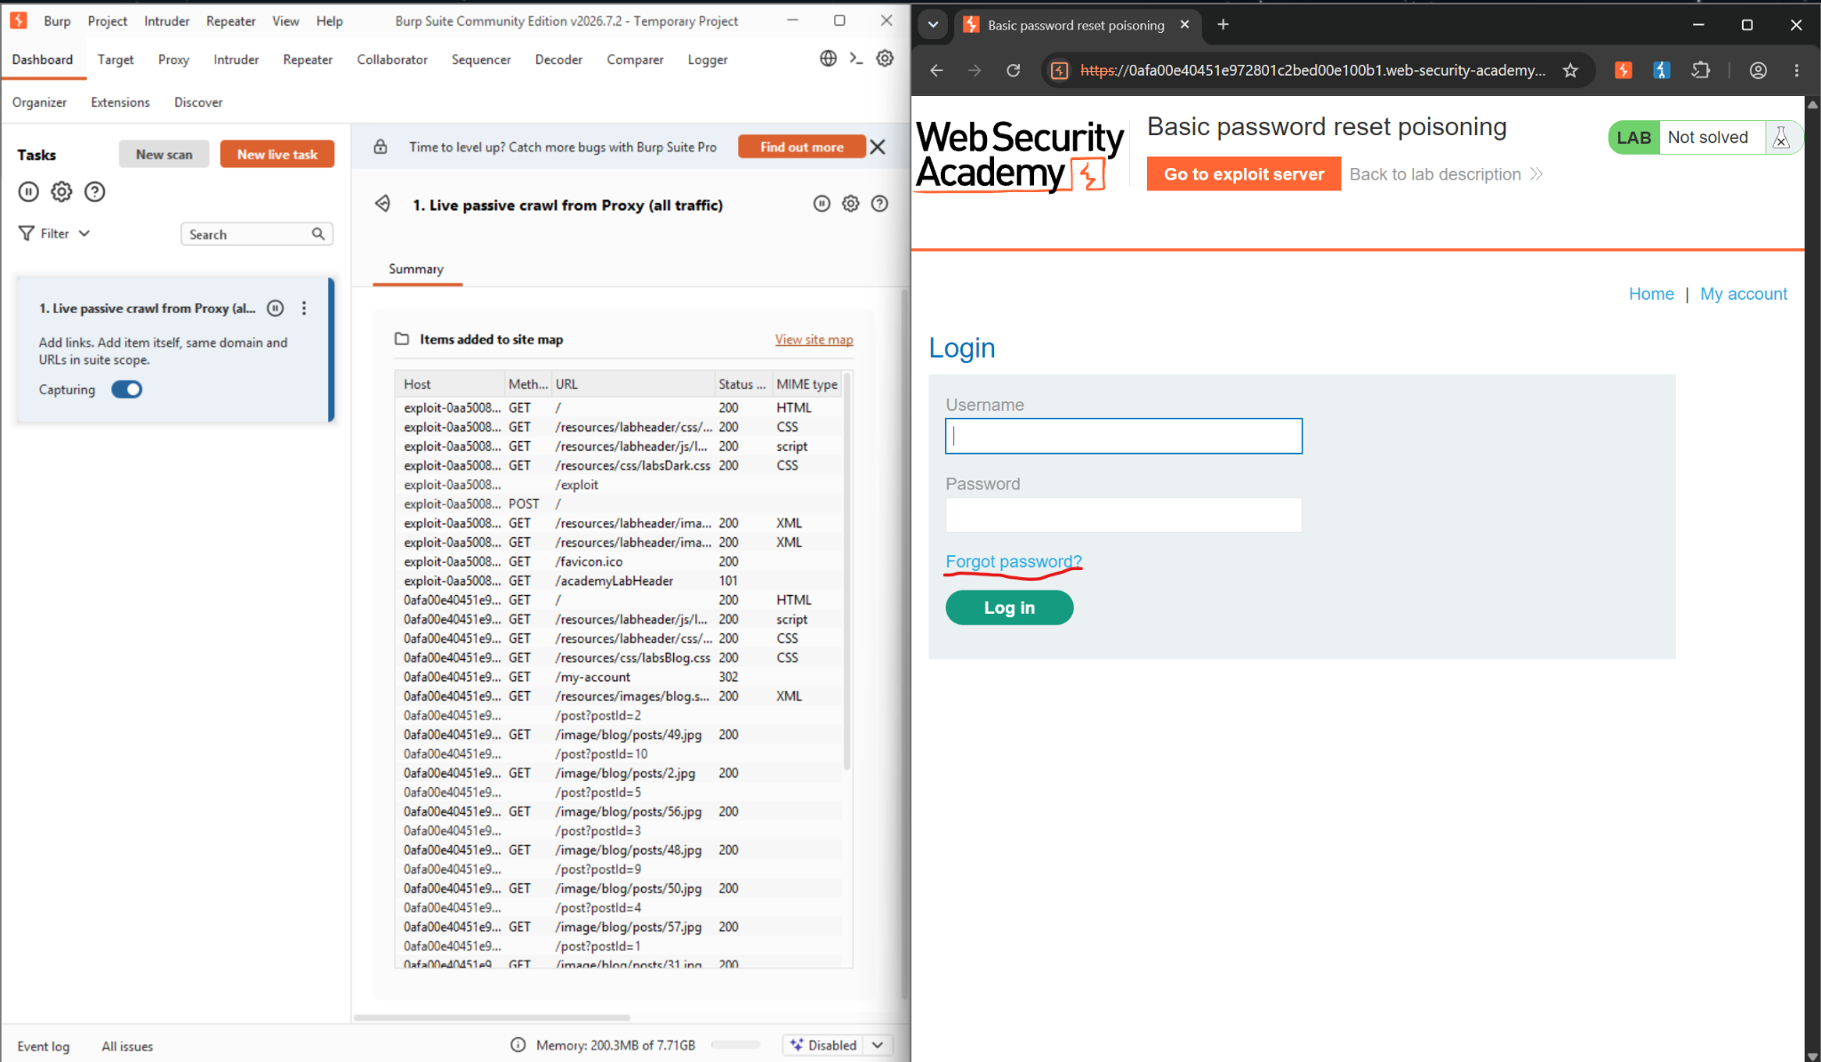
Figure 1: Burp Suite HTTP History showing the GET /forgot-password request, alongside the “Basic password reset poisoning” lab page

Step 2—Inspect the reset email.
The exploit server's mail client shows the generated reset email. The link's domain matches the request's Host header, and the link carries a temp-forgot-password-token query parameter—this token is what the reset flow ultimately trusts.

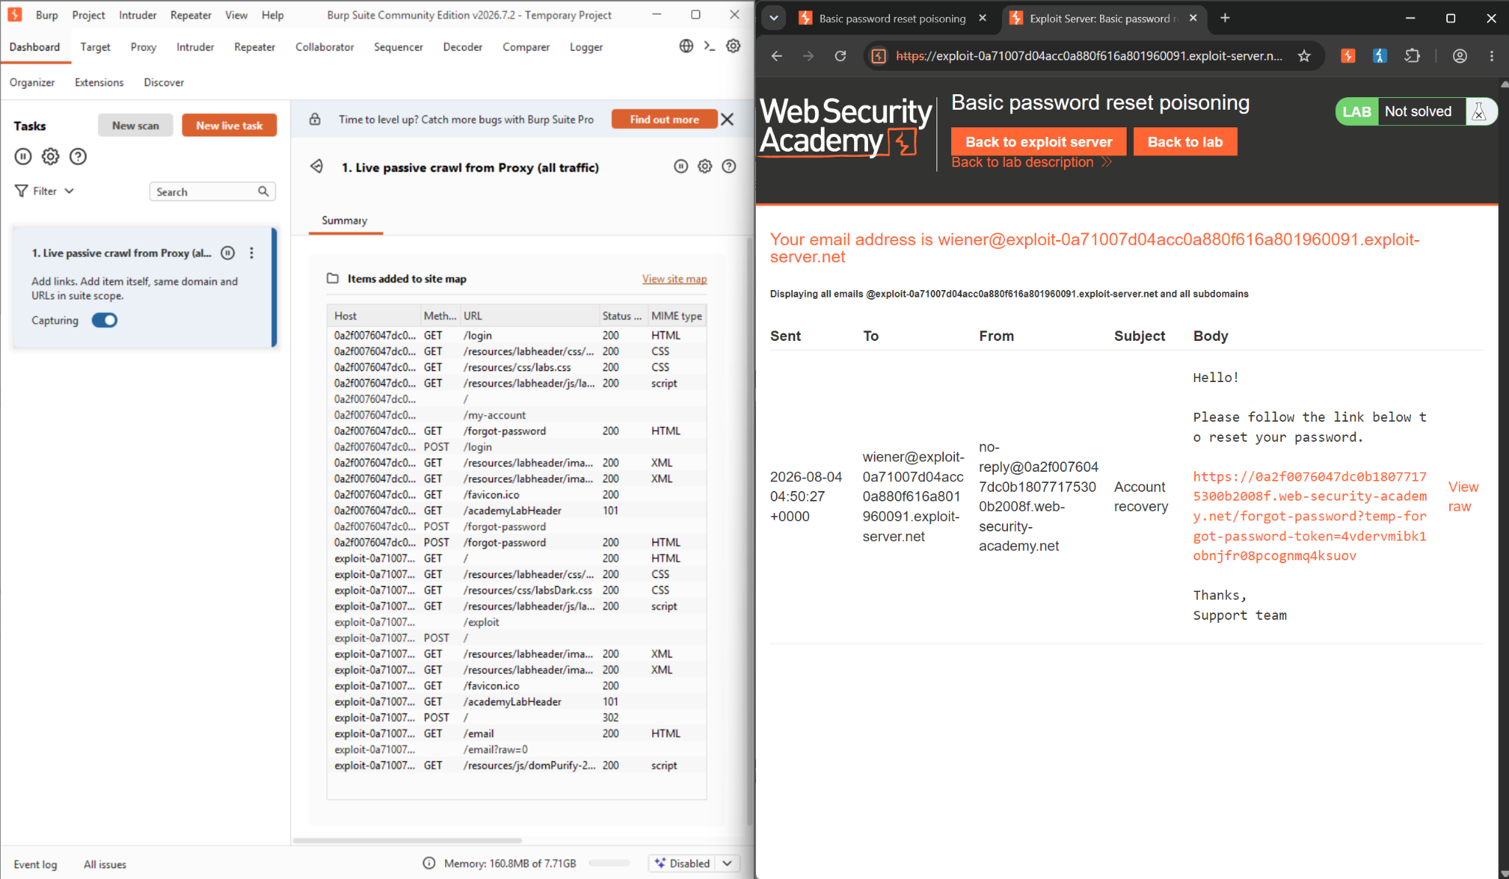
Figure 2: Reset email received on the exploit server, showing the reset link with its temp-forgot-password-token parameter.
Step 3 — Reset the password.
After getting the password reset link, we reset the password to peter.
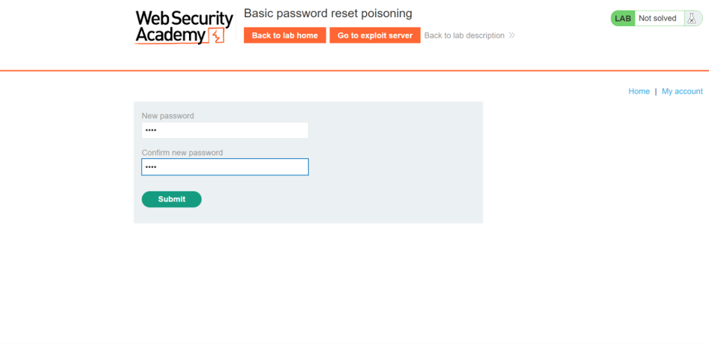

Figure 3: Password reset form, reached via the legitimate reset link

Step 4 — Capture the reset request in Proxy history.
After resetting the password, the corresponding POST /forgot-password request was located in Burp Proxy's HTTP History, ready to be sent to Repeater for manipulation.
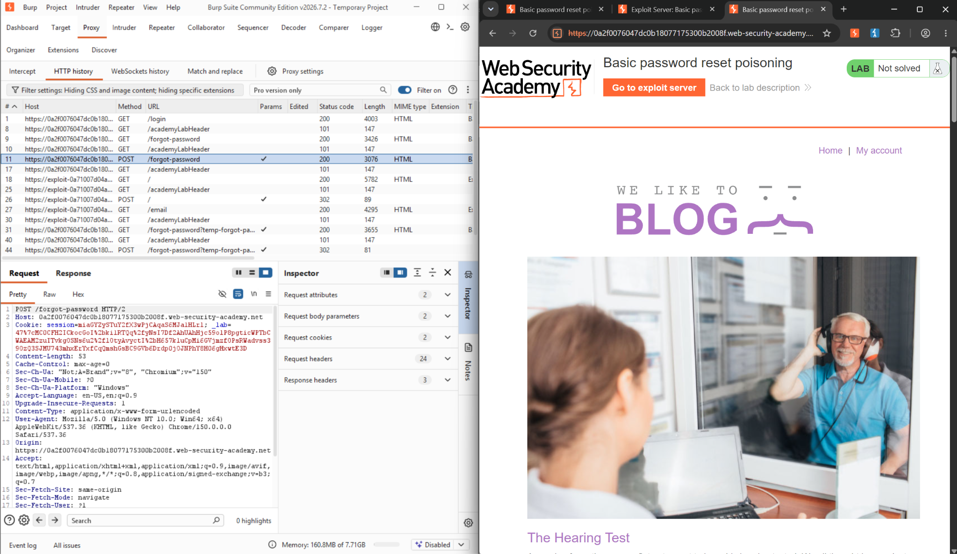
Figure 4: Burp Proxy HTTP History with the POST /forgot-password request selected

Step 5 - Send the request to Repeater.
Right-clicking the captured request and choosing “Send to Repeater” (Ctrl+R) moves it into Repeater for controlled, repeatable editing.
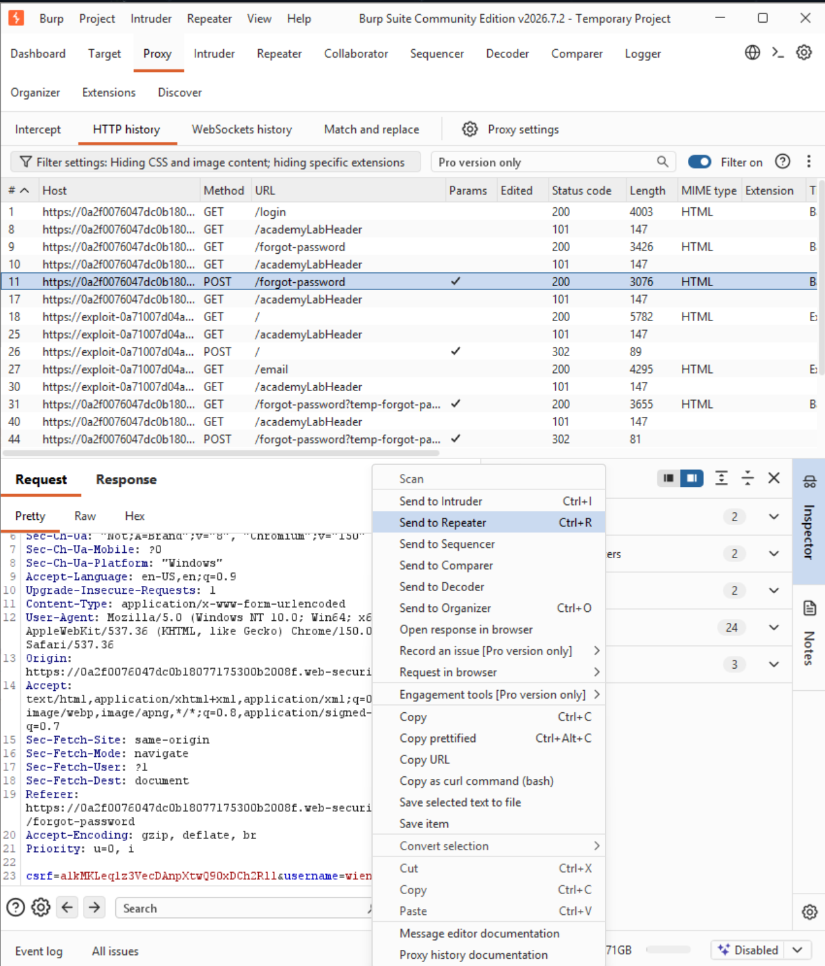
Figure 5: Sending the captured POST /forgot-password request to Repeater
Step 6- Select the Host header.
In Repeater, the Host header value (the legitimate lab domain) was highlighted — this is the field the application should validate, but does not.

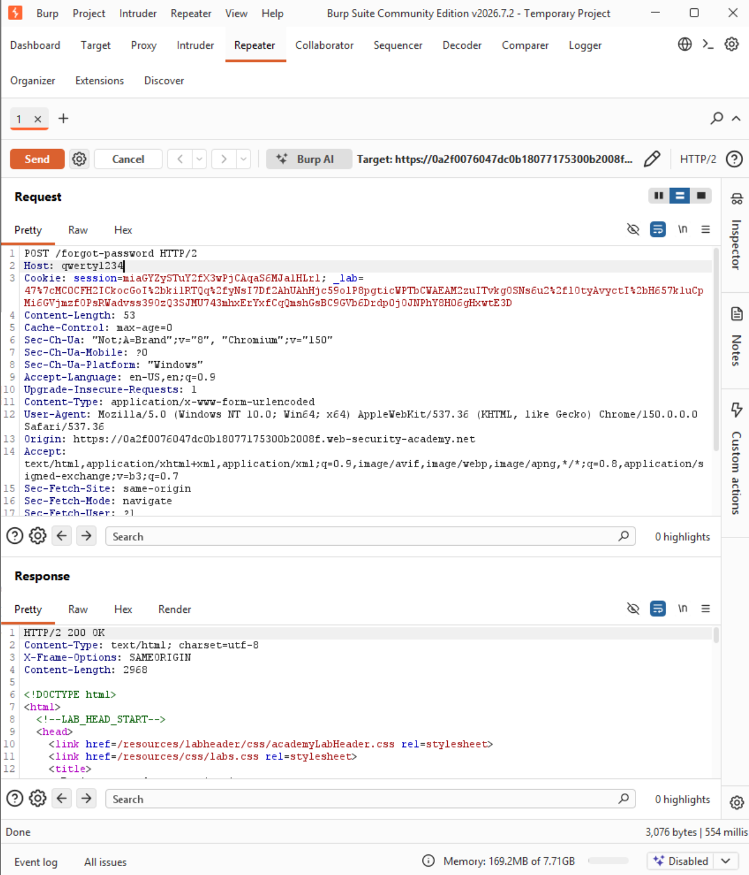
Figure 6: Repeater view with the Host header modified

Step 7- Confirm reflection in a fresh reset email.
Refreshing the exploit-server inbox showed a new reset email whose link domain matched the injected Host value, confirming the server does not validate the Host header before embedding it in the reset link.
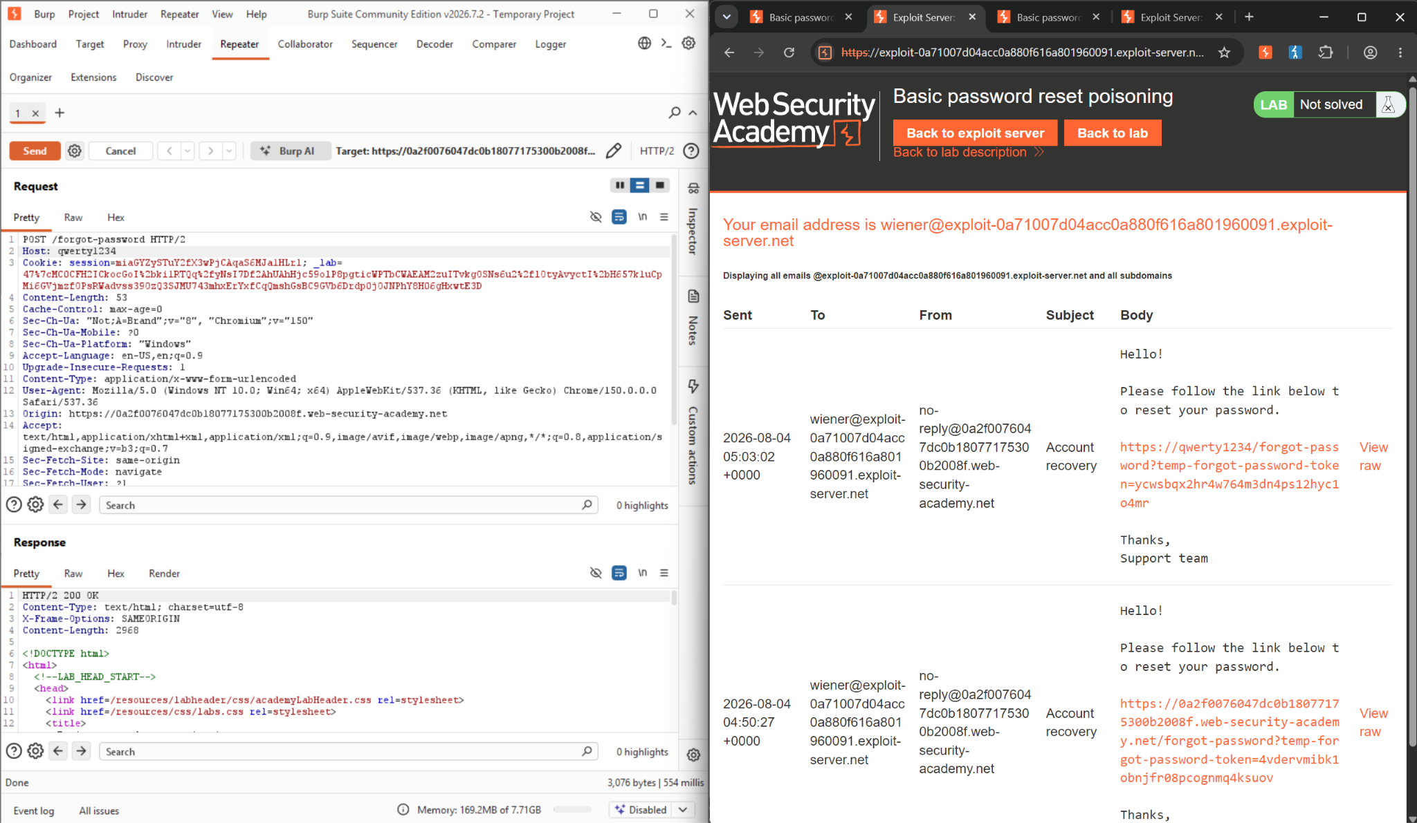
Figure 7: New reset email with the poisoned Host value reflected in the link domain, confirming the vulnerability

Step 8- Poison the reset request for the victim.
In Repeater, the Host header was changed to the exploit server's domain (exploit-0a71007d04acc0a880f616a801960091.exploit-server.net), and the username parameter in the body was changed to carlos. Sending this request asks the application to generate a password-reset email for carlos, but with the reset link pointing at the attacker-controlled exploit server instead of the real site.

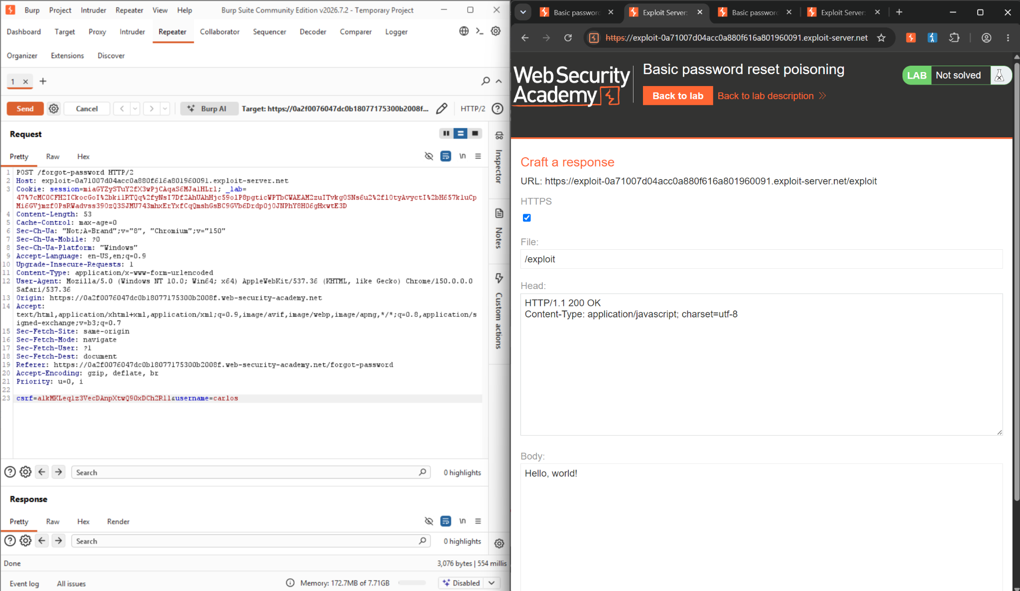
Figure 8: Change the host to exploit-0a71007d04acc0a880f616a801960091.exploit-server.net and change the username to carlos

Step 9- Capture the leaked token from the exploit server's access log.
The lab's simulated victim (carlos) automatically opens any link sent to him. Because the poisoned email pointed at the exploit server, carlos's client made a request there — visible in the access log as a hit from a distinct IP with user-agent "Victim": GET /forgot-password?temp-forgot-password-token=kywweru6wq74cu2ianltbmcaij0l6w18. The server returned a 404 (since /forgot-password doesn't exist on the exploit server), but the token itself was now exposed to the attacker in the log line.

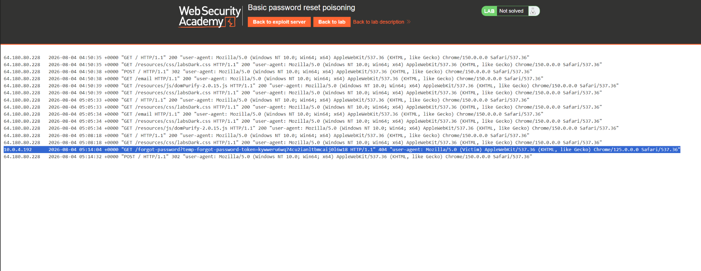

Figure 9: After the change, we get temp-forgot-password-token
Step 10- Rebuild a working reset link on the real domain.
The leaked token is only useful on the actual application, not the exploit server. The stolen token was substituted into a reset URL on the legitimate lab domain (.web-security-academy.net/forgot-password?temp-forgot-password-token=...), producing a link the real server would accept.
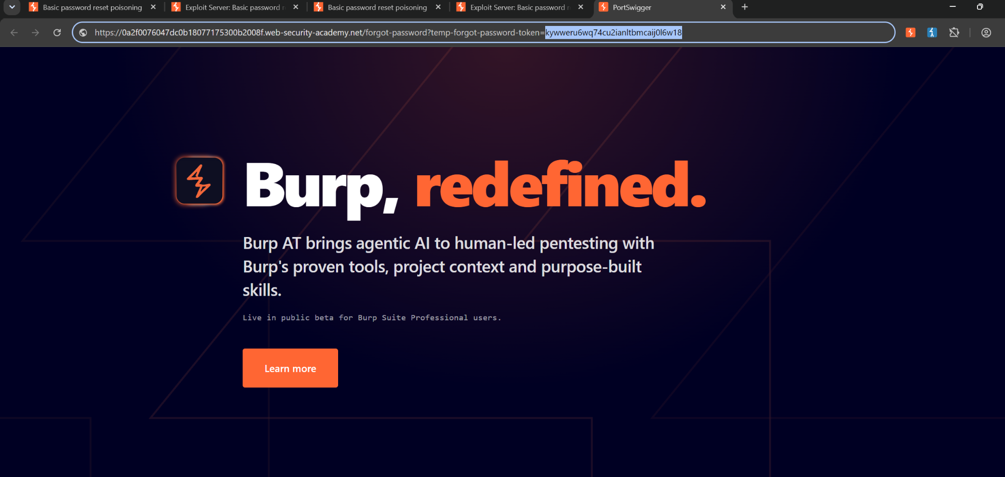
Figure 10: We replace the token generated in step 9 and add it to the original password reset link.

Step 11- Use the stolen token to reset carlos's password.
Navigating to that reconstructed link brought up the genuine password-reset form for carlos's account—the server accepted the leaked token as valid proof of identity. The password was set to peter.
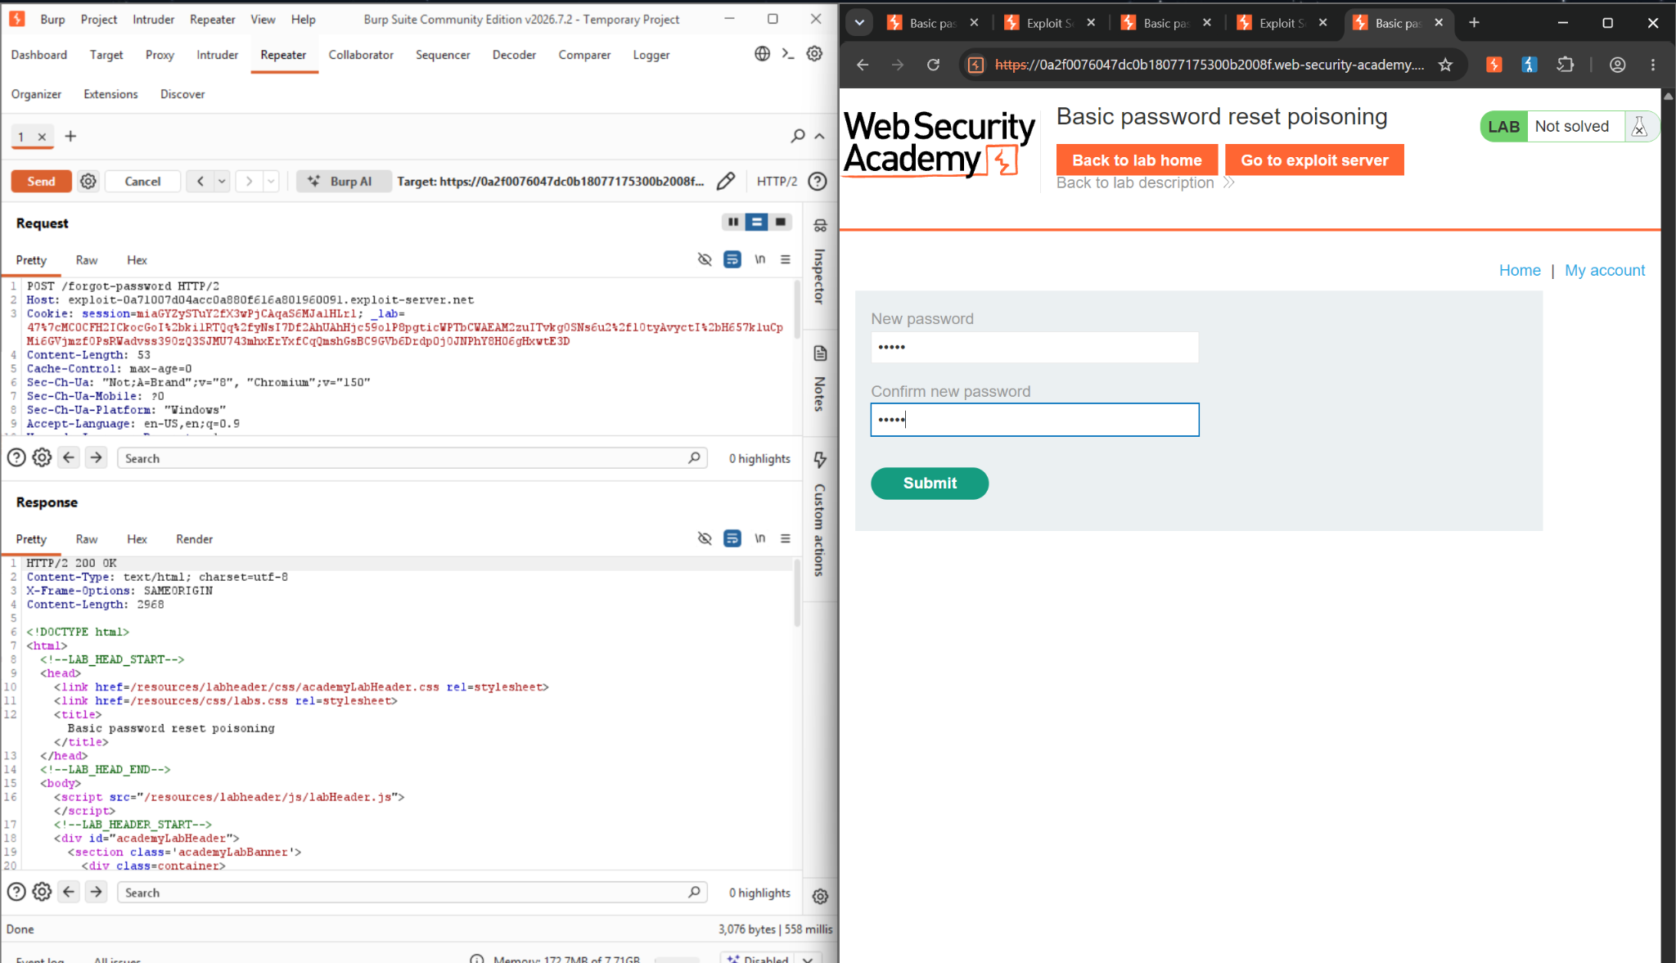
Figure 11: After the link is opened, we reset the password to peter

Step 12- Log in as the victim.
With the password now known, the login form was submitted using carlos / peter, authenticating as the victim account without ever knowing the original password.
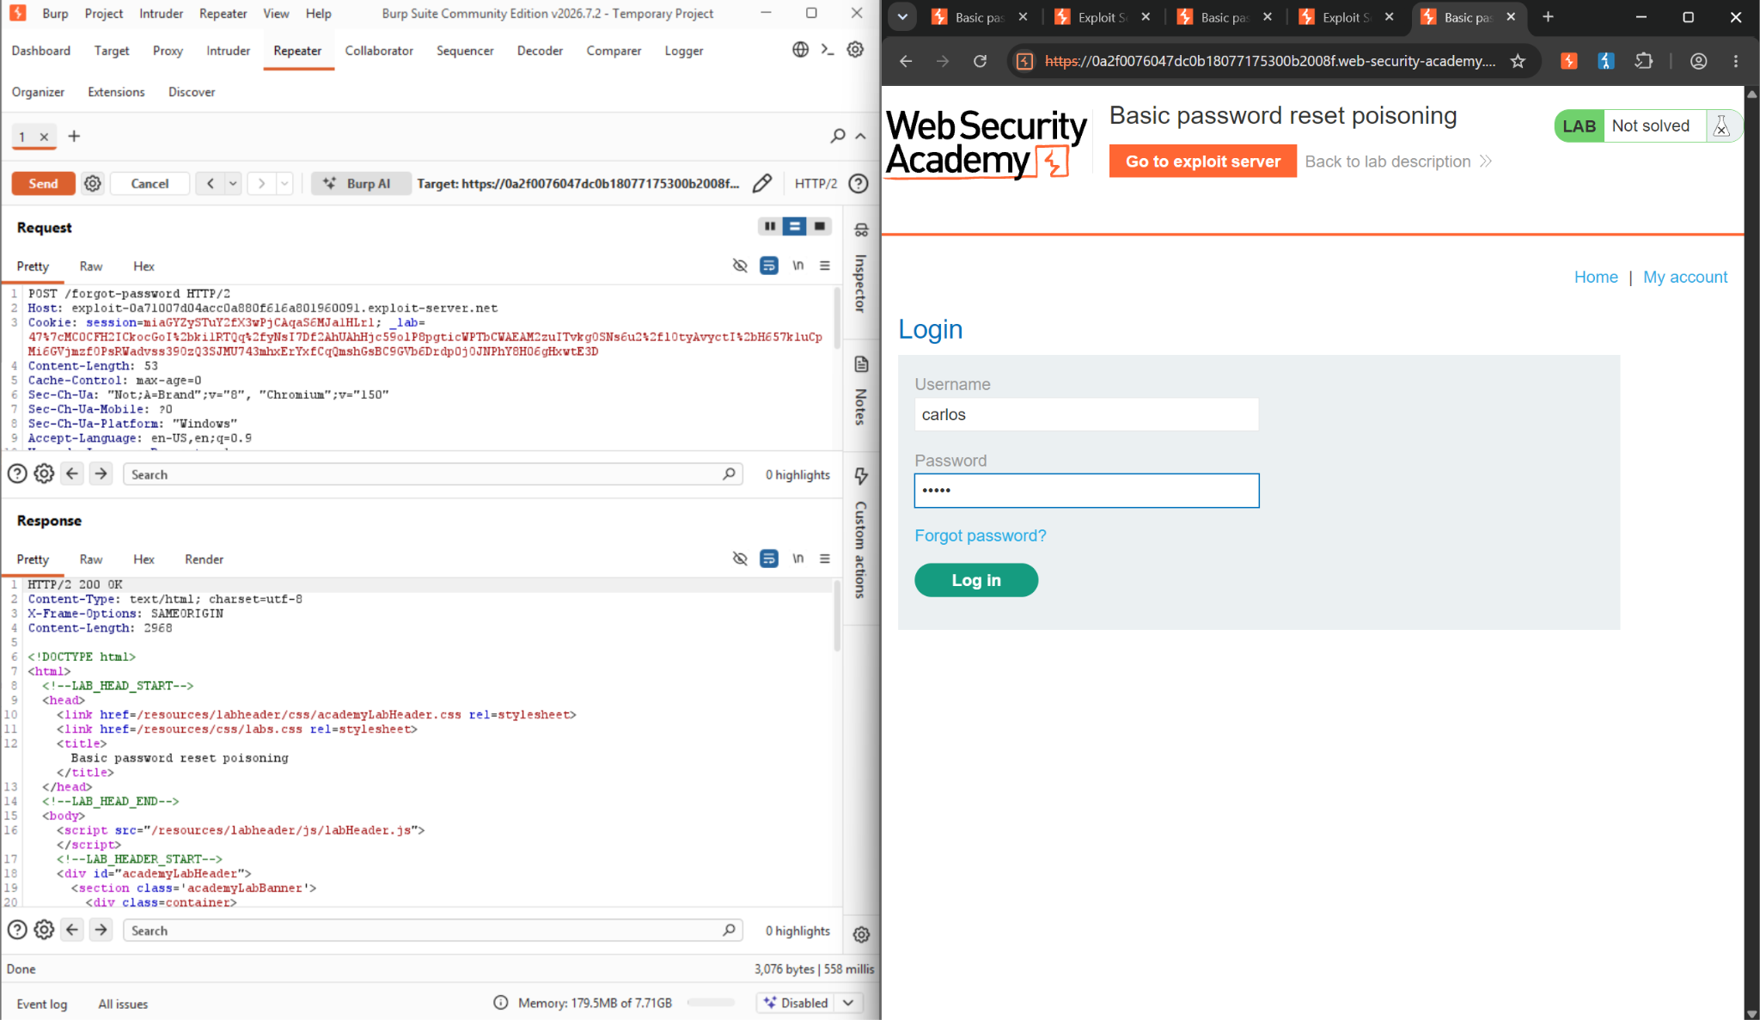
Figure 12: We log in using username carlos and password peter

Step13- Confirm account takeover.
The application's "Lab Solved" banner and the My Account page (showing username carlos, email carlos@carlos-montoya.net) confirm full takeover of the victim's account, closing the loop from Step 1's Host header injection to a complete account compromise.

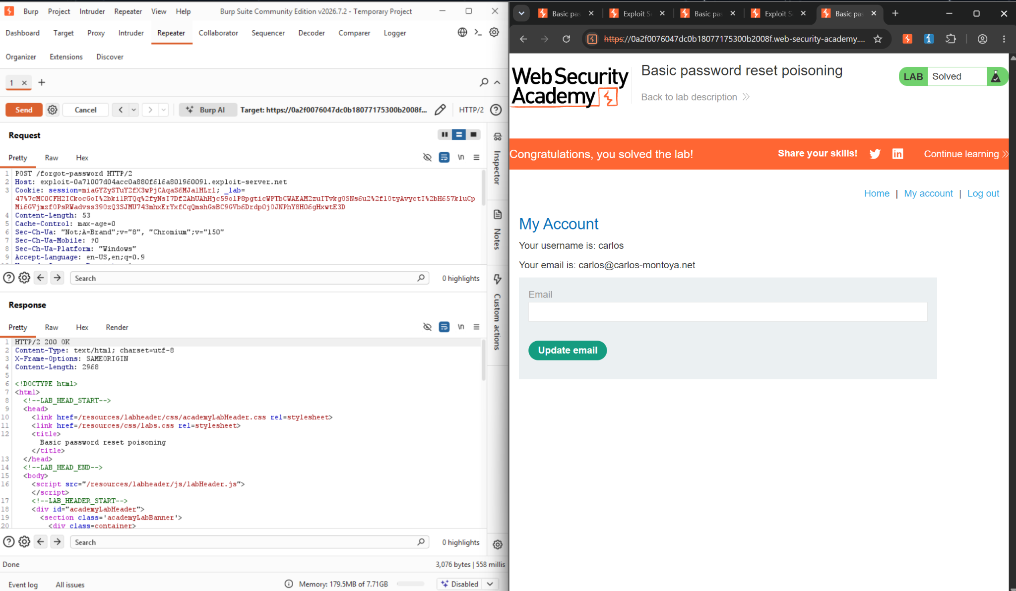
Figure 12: We logged n using username carlos and password peter and the lab is solved.

2.6 Impact Assessment
This problem lets someone take over your account without needing your password. All they need is your username or email address to start the process. They send a password reset email, and then they get the special code from their own server. They use this code to make a password and log in as you. The bad person does not have to do anything after they ask for a password reset. They can even use a computer program to try this on accounts at the same time. We tried this out in a lab. It worked. This means the problem is real, and someone can actually use it to hurt people; it is not something that might happen in theory.

2.7 Remediation

● Do not trust the Host header for generating security-sensitive URLs. Use a fixed, server-side configured base domain when building password-reset (or any other) links.

● If a dynamic Host is genuinely required (e.g. multi-tenant deployments), validate it against a strict allow-list of known-good domains before use, and reject or ignore unrecognized values.

● Bind reset tokens to the session or account that requested them, and invalidate a token if it is used from an unexpected origin.

● Apply a short expiry window to reset tokens and invalidate them immediately after first use, so a leaked token has a narrow window of usefulness.

● Log and alert on password-reset requests whose Host header does not match the application's expected domain, as an early indicator of this exact attack.

● Consider requiring a secondary confirmation step (e.g. re-authentication or a code delivered via a separate channel) before a password change takes effect.

2.8 Conclusion
This exercise showed us the full password reset poisoning attack against the "password reset poisoning" lab. We started with finding the problem. Ended with taking over the account. The main issue was found in Steps 1 to 7. The problem is that the application uses a Host header that the client supplies without checking it. This header is used to make the password reset links.

Steps 8 to 13 used this issue to attack Carlos's account. We did this by changing Carlos' password reset request. Then we took the token that Carlos got from the exploit server's log. We used this token to reset Carlos's password on the application. Finally, we logged in as Carlos to make sure we had taken over the account.

The labs "Solved" message and the Carlos account details we saw in Step 13 prove that this issue is real and can be used to attack the application. We did not need to know Carlos' username or password to do this. The application was vulnerable because it trusted a header that the client controlled.

The main thing to learn from this is that even a simple header, like Host, can be used to attack the application if it is used for something. To fix this issue, we should not just check the header to make sure it is safe. Instead, we should stop using it for this purpose. We should use a domain that the server trusts and a token that is connected to the account and session that asked for it.

References
1. Cloudflare—What is HTTP? https://www.cloudflare.com/learning/ddos/glossary/hypertext-transfer-protocol-http/
2. http.dev — HTTP Methods. https://http.dev/methods
3. http.dev — HTTP Status Codes. https://http.dev/status
4. MDN Web Docs — HTTP Headers. https://developer.mozilla.org/en-US/docs/Web/HTTP/Reference/Headers
5. Cloudflare — What Are Cookies? https://www.cloudflare.com/learning/privacy/what-are-cookies/
6. Kelp Docs — HTTP Request Parameters. https://docs.kelp.app/concepts/http-request-parameters
7. PortSwigger — Burp Proxy. https://portswigger.net/burp/documentation/desktop/tools/proxy
8. PortSwigger — Proxy HTTP History. https://portswigger.net/burp/documentation/desktop/tools/proxy/http-history
9. PortSwigger — Repeater. https://portswigger.net/burp/documentation/desktop/tools/repeater/http-messages
10. PortSwigger Web Security Academy — Basic password reset poisoning. https://portswigger.net/web-security/host-header/exploiting/password-reset-poisoning/lab-host-header-basic-password-reset-poisoning
11. PortSwigger Web Security Academy — Host header attacks (background reading). https://portswigger.net/web-security/host-header

